**Customer Churn Analysis**

Weekly Report

Ahmedabad University

4rier Series

Prof. Mehul Raval

CSE523 - Machine Learning

**Feature Selection**

L1 Regualrization

The penalty **α∑ni=1|wi|** is added to the loss function via L1 regularisation (L1-norm). Because each non-zero coefficient increases the penalty, weak features must have zero coefficients. As a result, L1 regularisation generates sparse solutions while also conducting feature selection.

In general, regularization is a technique used to prevent overfitting in machine learning models by adding a penalty term to the loss function that encourages the model to have smaller coefficients. L1 regularization adds a penalty term proportional to the sum of the absolute values of the coefficients. This is particularly useful in cases where there are many input features that may not be relevant to the output, as it can effectively remove these irrelevant features from the model.

**from sklearn.svm import LinearSVC**

**from sklearn.feature_selection import SelectFromModel**

**lsvc = LinearSVC(C=0.01, penalty="l1", dual=False, max_iter=1000).fit(X, y)**

**model = SelectFromModel(lsvc, prefit=True)**

**X_new = model.transform(X)**

**print(lsvc.coef_)**

**print(model.get_support())**

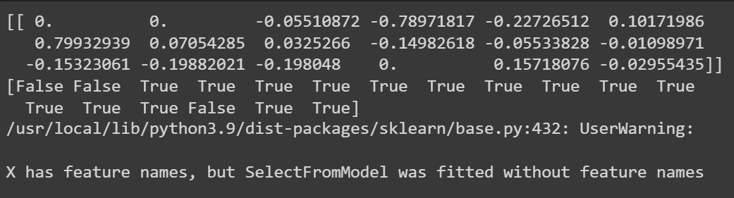**Important Parameters of Models Used**

**Logistic Regression**

| class sklearn.linear_model.LogisticRegression(penalty='l2', *, dual=False, tol=0.0001, C=1.0, fit_intercept=True, intercept_scaling=1, class_weight=None, random_state=None, solver='lbfgs', max_iter=100, multi_class='auto', verbose=0, warm_start=False, n_jobs=None, l1_ratio=None)[source] |
| --- |

Important Parameters

* fit_interceptbool, default=True

Specifies if a constant (a.k.a. bias or intercept) should be added to the decision function.

Provides a ridge regression style bias in case one knows the

* class_weightdict or ‘balanced’, default=None

Weights for the respective classes.

* C: float, default=1.0

C is the inverse of the regularization strength

<https://scikit-learn.org/stable/modules/generated/sklearn.linear_model.LogisticRegression.html#sklearn.linear_model.LogisticRegression>

Support Vector Classification

| class sklearn.svm.SVC(*, C=1.0, kernel='rbf', degree=3, gamma='scale', coef0=0.0, shrinking=True, probability=False, tol=0.001, cache_size=200, class_weight=None, verbose=False, max_iter=-1, decision_function_shape='ovr', break_ties=False, random_state=None) |
| --- |

* Cfloat, default=1.0

Regularization parameter. The strength of the regularization is inversely proportional to C. Must be strictly positive. The penalty is a squared l2 penalty.

* degreeint, default=3

Maximum degree of the polynomial function

* gamma{‘scale’, ‘auto’} or float, default=’scale’

This is known as the kernel coefficient which allows one to choose the scale i.e. rbf, poly or sigmoid.

* if gamma='scale' (default) is passed then it uses 1 / (n_features * X.var()) as value of gamma,
* if ‘auto’, uses 1 / n_features
* if float, must be non-negative.
* coef0float, default=0.0

Independent term in kernel function. It is only significant in ‘poly’ and ‘sigmoid’.

* class_weightdict or ‘balanced’, default=None

Set the parameter C of class i to class_weight[i]*C for SVC

**Naive Bayes Classifier**

| class sklearn.naive_bayes.GaussianNB(*, priors=None, var_smoothing=1e-09) |
| --- |

* priorsarray-like of shape (n_classes,), default=None

Prior probabilities of the classes. If specified, the priors are not adjusted according to the data.

* var_smoothingfloat, default=1e-9

Portion of the largest variance of all features that is added to variances for calculation stability.

<https://scikit-learn.org/stable/modules/generated/sklearn.naive_bayes.GaussianNB.html>

**References**

*sklearn.linear_model.LogisticRegression*. (n.d.). Scikit-learn. <https://scikit-learn/stable/modules/generated/sklearn.linear_model.LogisticRegression.html>

*sklearn.naive_bayes.GaussianNB*. (n.d.). Scikit-learn. <https://scikit-learn/stable/modules/generated/sklearn.naive_bayes.GaussianNB.html>

*sklearn.svm.SVC*. (n.d.). Scikit-learn. <https://scikit-learn/stable/modules/generated/sklearn.svm.SVC.html>